LAB 2- CREATE database
A. Creating Database ‘PropertyManagement’
- On the phpMyAdmin screen, select SQL tab.
- The basic syntax of this CREATE DATABASE statement is as follows:
CREATE DATABASE DatabaseName;

- Type above syntax with databasename = ‘PropertyManagement’, then click go.

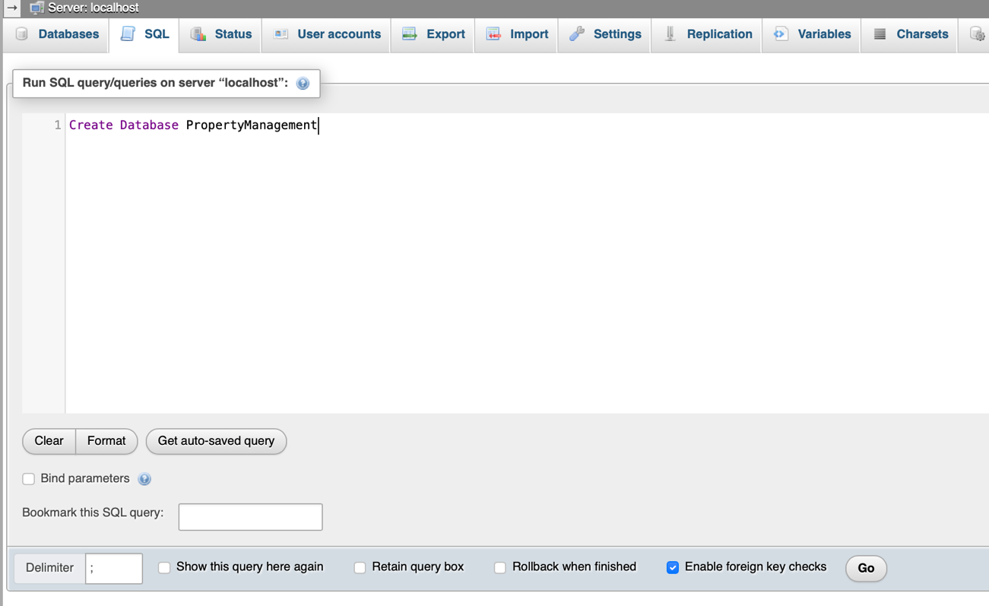

- After executing the command, a message indicating that the database has been created is shown.
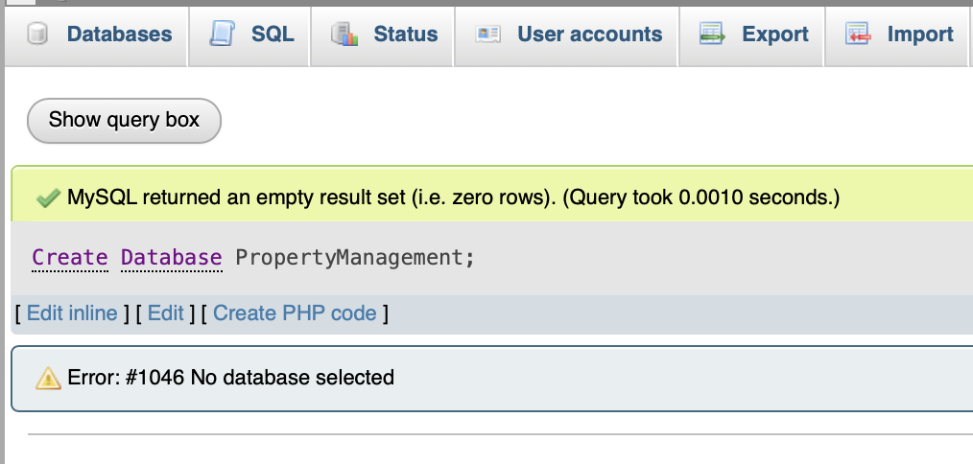

- To list all the database that has been successfully created, type syntax below, then click go.

SHOW DATABASES

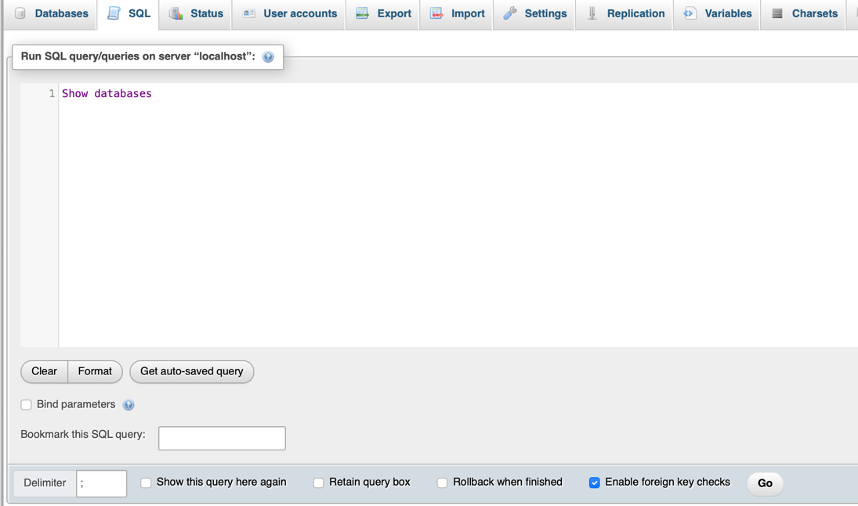

List of databases

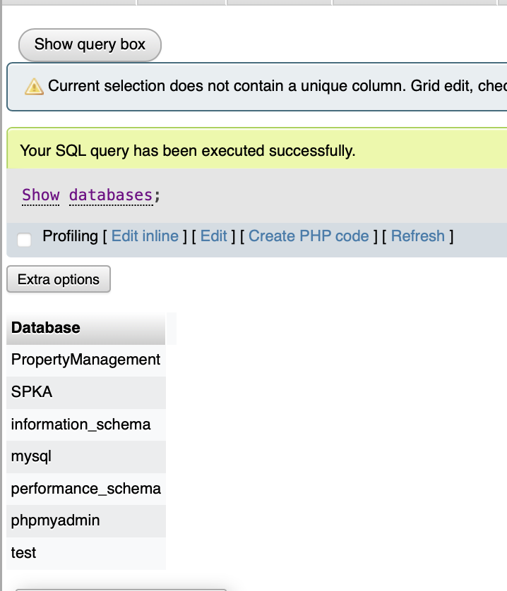

B. Delete Database ‘PropertyManagement’
- To delete database, used syntax below:
SQL Syntax:
DROP DATABASE DatabaseName;

Example:
DROP DATABASE PropertyManagement

- To verify whether it successfully deleted, list all databases using the syntax below:
SHOW DATABASES

- This will display a list of all the databases, and PropertyManagement is not in the list.

C. DATA TYPE
SQL Data Type is an attribute that specifies the type of data of any object. Each column, variable and expression has a related data type in SQL.

- Exact Numeric Data Types
DATA TYPE | FROM | TO
bigint | -9,223,372,036,854,775,808 | 9,223,372,036,854,775,807
int | -2,147,483,648 | 2,147,483,647
smallint | -32,768 | 32,767
tinyint | 0 | 255
bit | 0 | 1
decimal | -10^38 +1 | 10^38 -1
numeric | -10^38 +1 | 10^38 -1
money | -922,337,203,685,477.5808 | +922,337,203,685,477.5807
smallmoney | -214,748.3648 | +214,748.3647

- Approximate Numeric Data Types
DATA TYPE | FROM | TO
float | -1.79E + 308 | 1.79E + 308
real | -3.40E + 38 | 3.40E + 38

- Date and Time Data Types
DATA TYPE | FROM | TO
datetime | Jan 1, 1753 | Dec 31, 9999
smalldatetime | Jan 1, 1900 | Jun 6, 2079
date | Stores a date like June 30, 1991
time | Stores a time of day like 12:30 P.M.

- Character Strings Data Types
Sr.No. | DATA TYPE & Description
1 | char  Maximum length of 8,000 characters.( Fixed length non-Unicode characters)
2 | varchar  Maximum of 8,000 characters.(Variable-length non-Unicode data).
3 | varchar(max)  Maximum length of 2E + 31 characters, Variable-length non-Unicode data (SQL Server 2005 only).
4 | text  Variable-length non-Unicode data with a maximum length of 2,147,483,647 characters.

